3- Tier Network Architecture

# Here in this report, The 3- tier network architecture is designed in such a way that both the devices on the either sides communicate with each other . The 3- tier network architecture is designed below:

Creating Network Architecture:

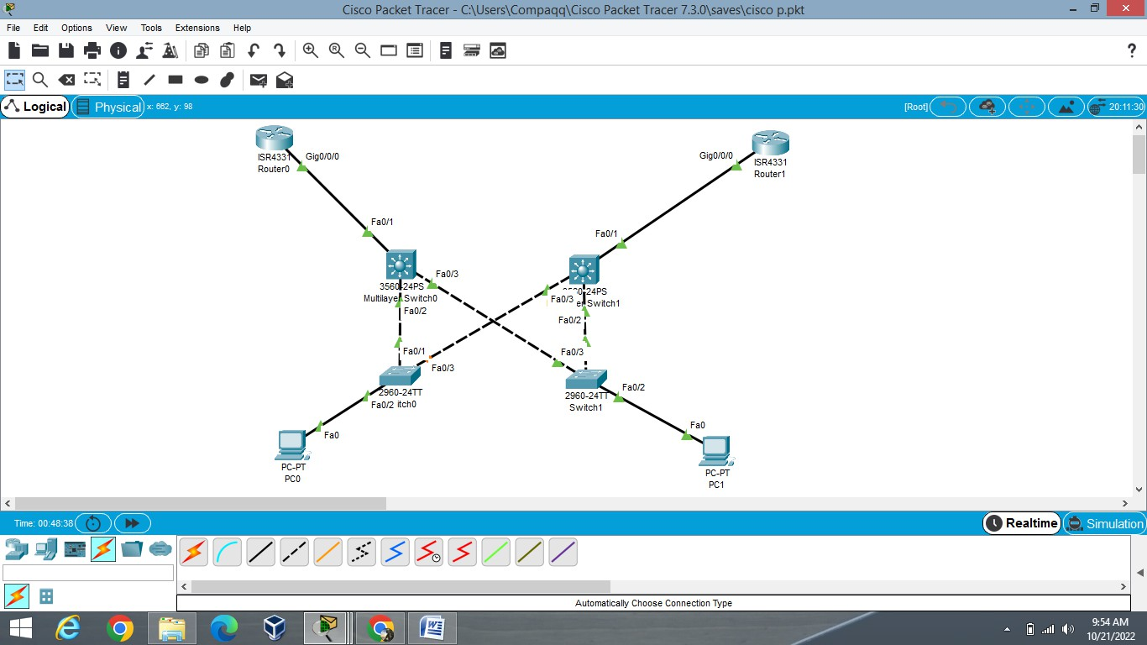

**Figure 1 NETWORK ARCHITECTURE**

# Here both computer devices communicate with each other and are connected through VLANS

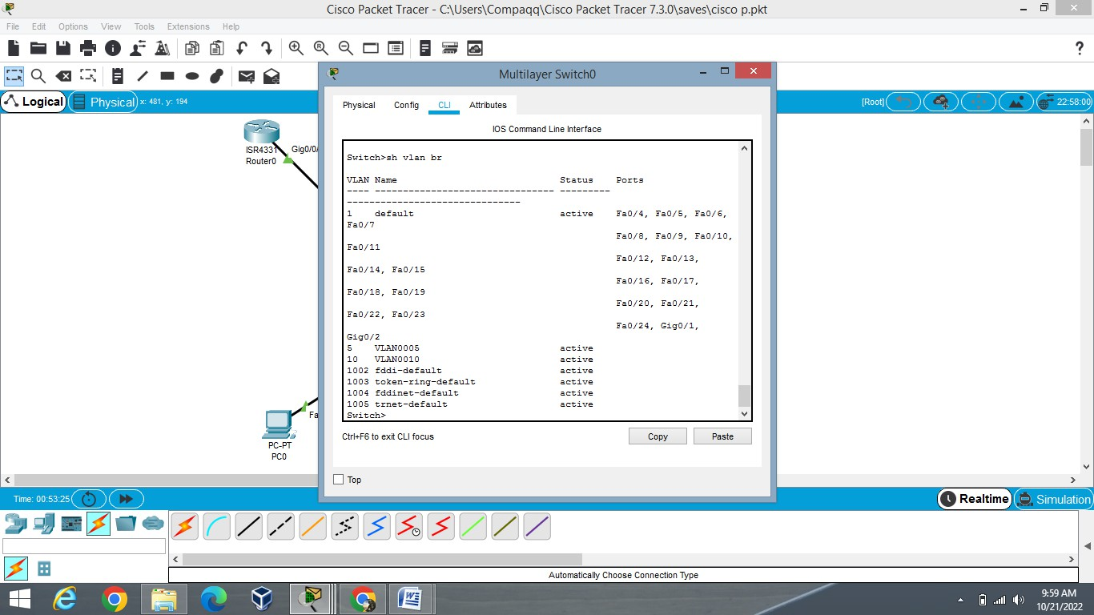

**Figure 2: VLAN assigned in multilayer switch**

Here two VLANS are assigned(VLAN 5 and VLAN 10).

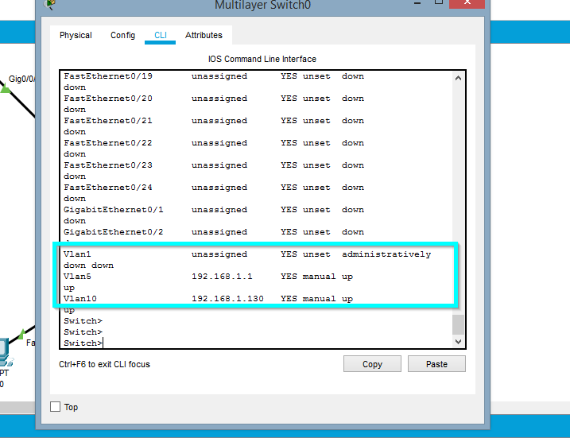

**Figure 3: VLAN IP assigned**

Here the IP in the VLANS are assigned as shown in the above figure.

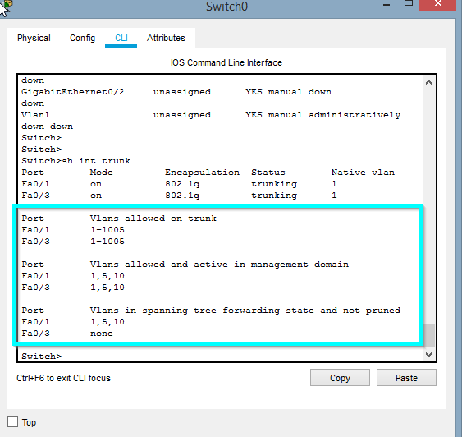

**Figure 4 TRUNKING BETWEEN PORTS**

Here Trunking is done between the ports and the VLAN 5 and VLAN 10.

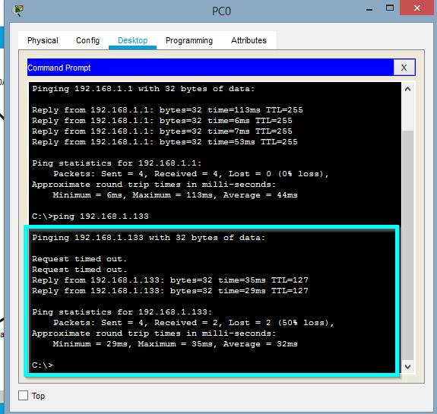

**Figure 5 PING**

Here The both computer on the other sides are ping together as shown in figure.

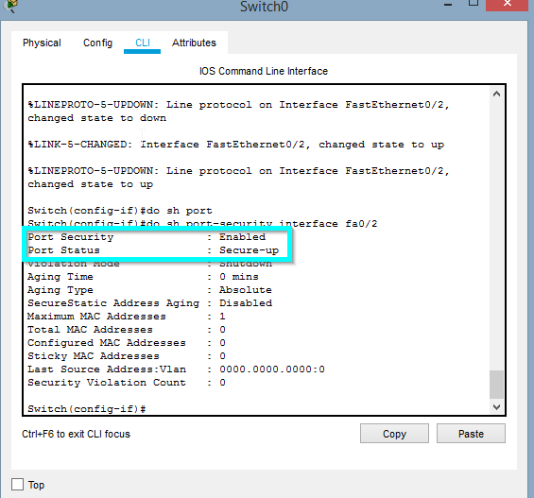

**Figure 6 PORT SECURITY**

Here The port Fa0/2 is Secured using port-security command.